National Utility Contractors Association
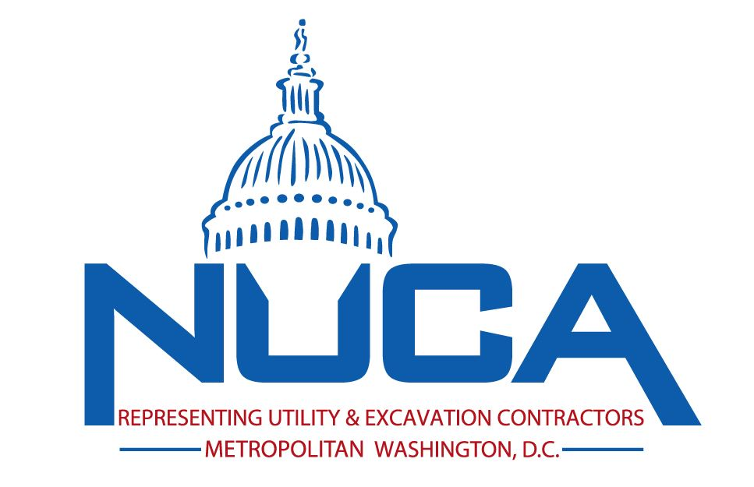
Metropolitan Washington DC Chapter
2021-2022 Activation Form for Associates/Suppliers

*SUPER 2021/2022 SPECIAL*
Pay 2021 membership Dues, and receive the full benefits of membership for 2021 AND 2022!

Associate Member: Any person, firm, corporation, nonprofit organization, association, or other non-governmental entity involved in the utility construction or excavation industry as a supplier of equipment, materials or services to contractors.

___ YES! We want to join NUCA of Metro DC and National Utility Contractors Association today. Sign us up for full privileges. This payment will cover our membership through 12/31/2022.

Select your Associate member dues based on your company’s total annual revenue:

Annual Revenue Total Due: includes your Metro DC Chapter and NUCA National Dues
_____Less than $2,000,000 $ 1,135
Who Recommended You Join NUCA?

_________________________________________________
_____$2,000,000-$10,000,000 $ 1,635
_____More than $10,000,000 $ 2,120
(please initial)________I attest the above total annual revenue to be true.

Questions? Contact NUCA of Metro DC Executive Director at (202) 607-7658 or email ED@nucaofdc.org.

Your Company:____________________________________________ Website: www._______________________

Company Address_______________________________________ City_______________ State____ Zip________

Main Contact’s Name:_______________________________________ Title:____________________________________

Email: __________________________________ Phone:_____________________ Fax:___________________________

Your Safety Professional’s Name:________________________________________ Email:________________________

Your Sales Associate’s Name:___________________________________________ Email:________________________

Your Company Executive’s Name:________________________________________ Email:________________________

I understand that $15 of my dues will be applied toward my subscription to Utility Contractor magazine. Both NUCA National and Chapter dues may be deducted as a business expense, but not as a charitable contribution. The Internal Revenue Service limits the amount of business expense deductions for dues paid to an association that engages in lobbying activities even if dues are not used for lobbying. The amount excluded for 2021 is 29% based on IRS criteria.

Select Your Payment Method:

___ Check Enclosed (payable to NUCA) ___ Visa ___ MasterCard ___ American Express
Card No.: ___________________________________________ CID No: ________ Expiration Date:
Card Holder Name: ________________________________________ Signature:
Remit Dues Payment to: NUCA of Metropolitan Washington DC, 455 Massachusetts Ave. N.W., Suite 150/502, Washington, DC 20001
Continued On Next Page
Check up to five products/services that best describe your company’s business:
(This is how you will be listed in the Utility Construction Buyers’ Guide and the online NUCA Membership Directory: www.nuca.com)

____P-DI Accounting Services
____P-A Aggregate Supplies
____P-C Air Tools
____P-B Air/Gas Monitors
____P-D Attachments
____P-E Auctioneers/Appraisers
____P-F Backhoe/Loaders
____P-G Banking Services
____P-H Barriers/Rails/Guards
____P-I Boring Equip.
____P-EA Breathing Apparatus
____P-J Buckets
____P-ES Cable Pulling Tools
____P-K Castings/Manholes/Grates
____P-L Compaction Attachments
____P-M Compactors
____P-N Compressors
____P-O Computers/Software/Supplies
____P-DH Concrete Precast Products
____P-P Concrete Products
____P-DE Confided Space Equip.
____P-Q Contractor Services
____P-R Conveyors
____P-S Couplings, Pipe
____P-T Cranes
____P-U Cutting Edges/Accessories
____P-DM Dewatering Equipment
____P-X Directional Drilling Equip.
____P-Y Drills
____P-Z Engineering Services
____P-AA Engines
____P-AB Environmental Services
____P-EB Equipment Leasing/Rental
____P-AC Equipment Sales
____P-EO Equipment, Internet Brokers
____P-DF Erosion Control Products
____P-AE Explosives/Demolition Supply
____P-ER Factoring Services
____P-DL Fences
____P-AF Financial Services
____P-EJ Footwear (Safety)
____P-EC Fork Lifts/Loaders
____P-AG Geotextiles/Fabrics
____P-AH Grapples
____P-AI Grinders
____P-BX Grounding
____P-AJ Grouting, Chemical
____P-AK Grouting, Pressure
____P-AL Hammer/Breaker Attachments
____P-AM Hazardous Waste Equip.
____P-AN Heavy Hauling Equip.
____P-AO Hydraulic Tools
____P-AV Industry Publication
____P-AP Insurance
____P-AQ Lasers
____P-AR Leak Detection
____P-AS Legal Services
____P-AT Lighting Equip.
____P-AU Loaders/Dozers
____P-AW Locators, Pipe/Cable
____P-DG Lubricants
____P-DB Magnetic Locating
____P-EK Manhole Rehabilitation
____P-ET Marketing/PR
____P-AX Material Suppliers
____P-AY Meters
____P-AZ Microtunneling Equip.
____P-ED One-Call Center
____P-EL Pavement Markings
____P-BA Pavers
____P-BB Paving Products
____P-BC Petroleum Products
____P-BD Pigs
____P-EQ Pile Driving Equip.
____P-BL Pipe Cutters
____P-BM Pipe Insulators
____P-BN Pipe Jacking Equip.
____P-EN Pipe Lifting Tongs
____P-BO Pipe Liners
____P-BQ Pipe Pullers/Pushers
____P-BR Pipe Stoppers
____P-BS Pipe Testing/Repair Equip.
____P-BE Pipe, Clay
____P-BF Pipe, Concrete
____P-BG Pipe, Corrugated Steel
____P-BH Pipe, Ductile Iron
____P-BI Pipe, Fiberglass
____P-BJ Pipe, Plastic
____P-BK Pipe, Steel
____P-BP Pipeline Accessories
____P-BT Pumps, Centrifugal
____P-BU Pumps, Hydrostatic Testing
____P-BV Pumps, Potable/Submersible
____P-BW Pumps, Sewers/Slurry
____P-EI Retaining Walls
____P-BZ Safety Consulting
____P-BY Safety Equip.
____P-CA Saws/Grinders/Blades
____P-CB Scrapers/Graders
____P-V Security/Theft Prevention
____P-CC Sewer Plugs
____P-CD Sewer/Water Maintenance
____P-CG Soil Stabilization Fluids
____P-EH Steel Fabricating
____P-EM Steel Sheet Piling
____P-CH Steel Supplies
____P-CF Storm Drainage
____P-CI Surety Bonding
____P-EG Survey Equip.
____P-CJ Tampers
____P-TC Technology Consulting
____P-CK Teeth
____P-CL Testing Equip.
____P-CM Testing Services
____P-W Tires
____P-CN Tools
____P-DJ Tracer Wire/Locate Wire
____P-CO Traffic Control Equip.
____P-CP Trailers
____P-CQ Training Services
____P-CR Trench Shields/Shoring
____P-CU Trenchers
____P-CS Trenchless Installation Equip.
____P-CT Trenchless Rehab. Equip.
____P-CV Trucks
____P-CX Tunnel/Shaft Liner Plate
____P-CW Tunneling Equip.
____P-EF Underground Supports
____P-EP Underground Utility Locating
____P-DK Vacuum Excavation
____P-CY Valves/Hydrants
____P-EE Vaults
____P-CZ Ventilation Equip.
____P-DA Water Supply Services
____P-DD Well Pointing Services
____P-DC Other

NUCA and its affiliates have permission to fax/email to the contacts listed (FCC requirement – please sign below.)

Your Signature Here: ____________________________________

►Remit Dues Payment to: NUCA of Metropolitan Washington DC,
455 Massachusetts Ave. N.W., Suite 150/502, Washington, DC 20001

Jamie Doll, President, NUCA of Metropolitan Washington DC
Phone: (202) 607-7658 Fax to: 202 930 5715 Scan & Email to: ED@nucaofdc.org
Website: www.nucaofdc.org

